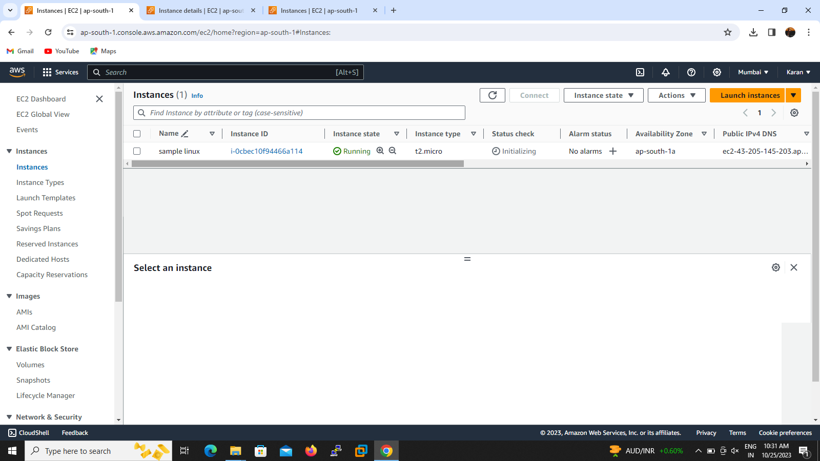

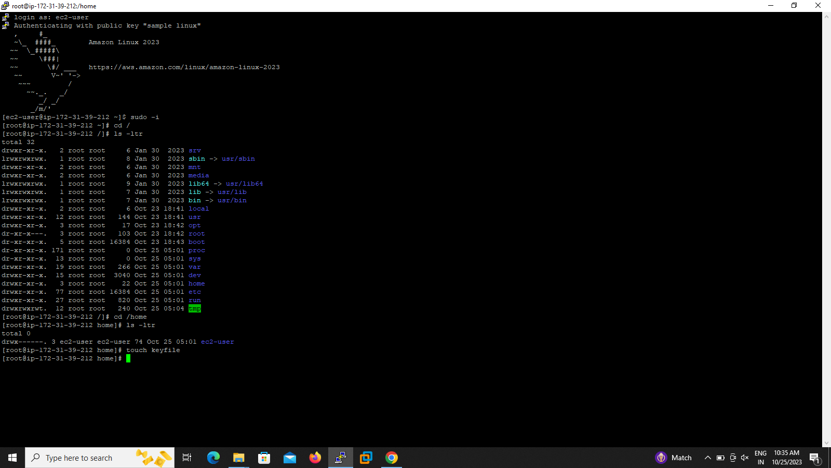

1.I create the sample server for this scenario and login to putty by using keyfile and public ip address then I create a new file for sampling purpose name called keyfile in /home/key file

2.i delete the sample server keyfile use the following methods to recover the date without data lose from the instance

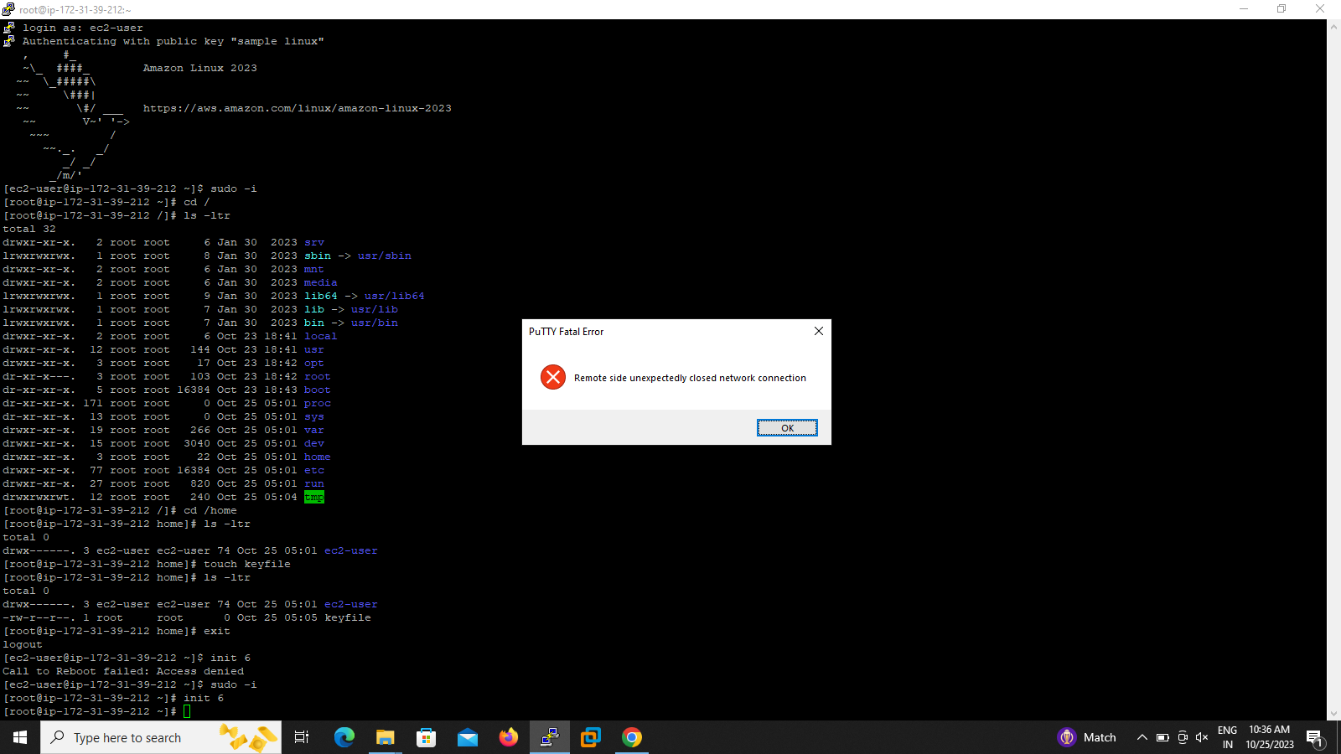

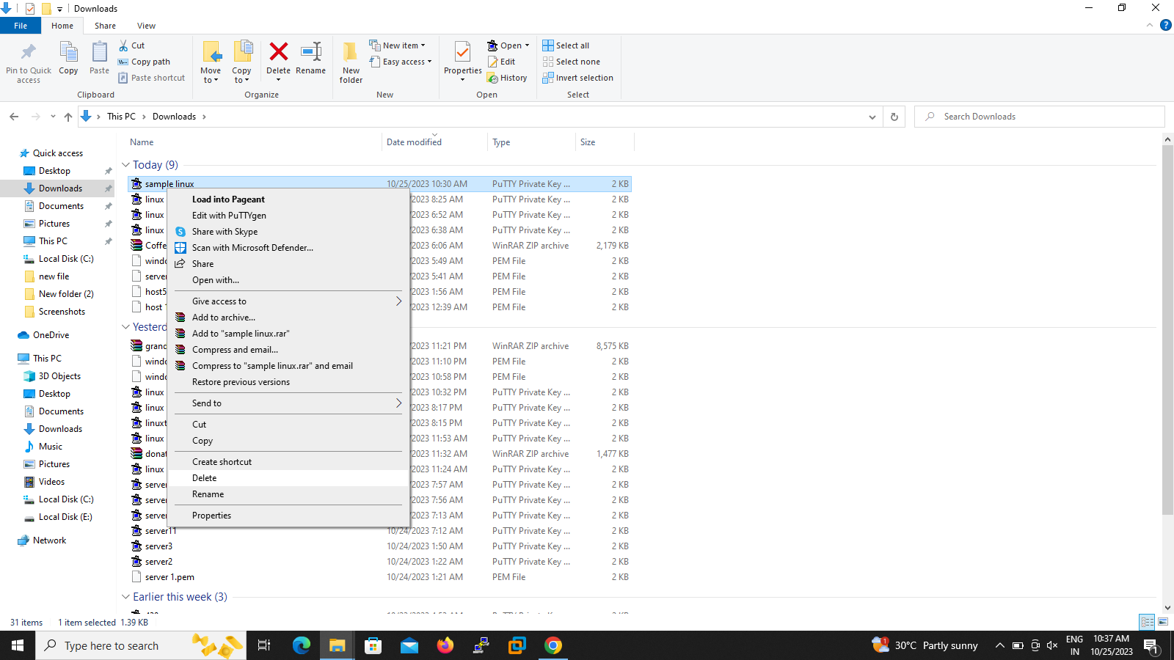

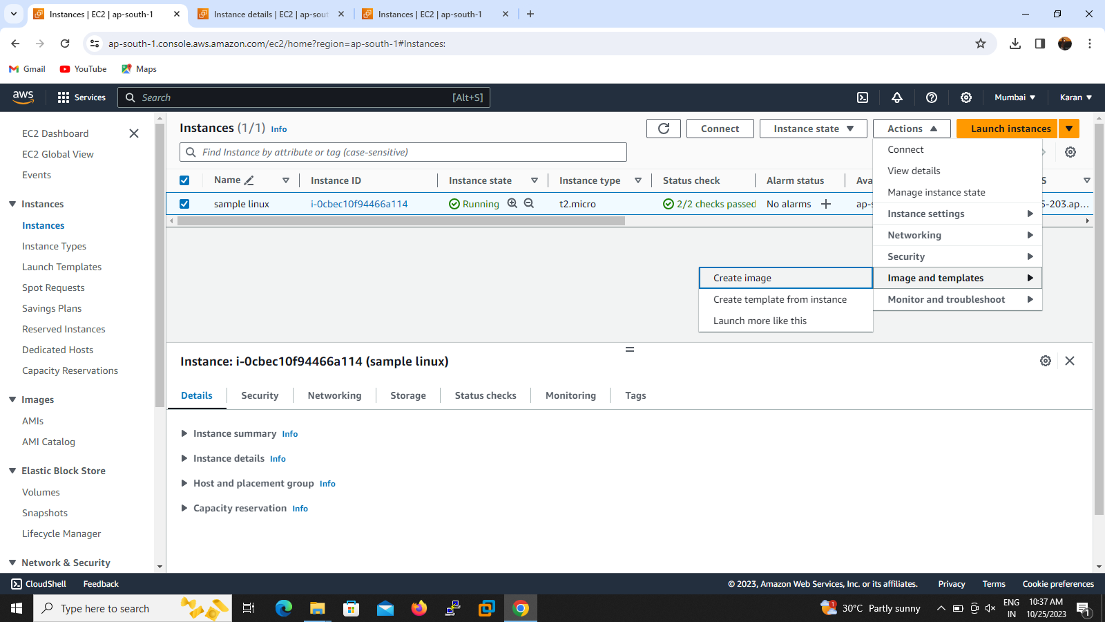

2. I create the new AMI from sample instance.To click the instance select image then create AMI image

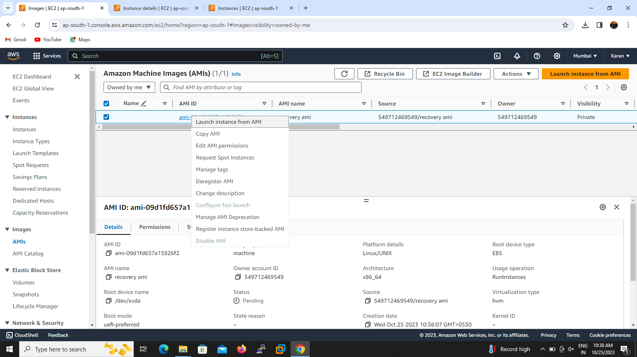

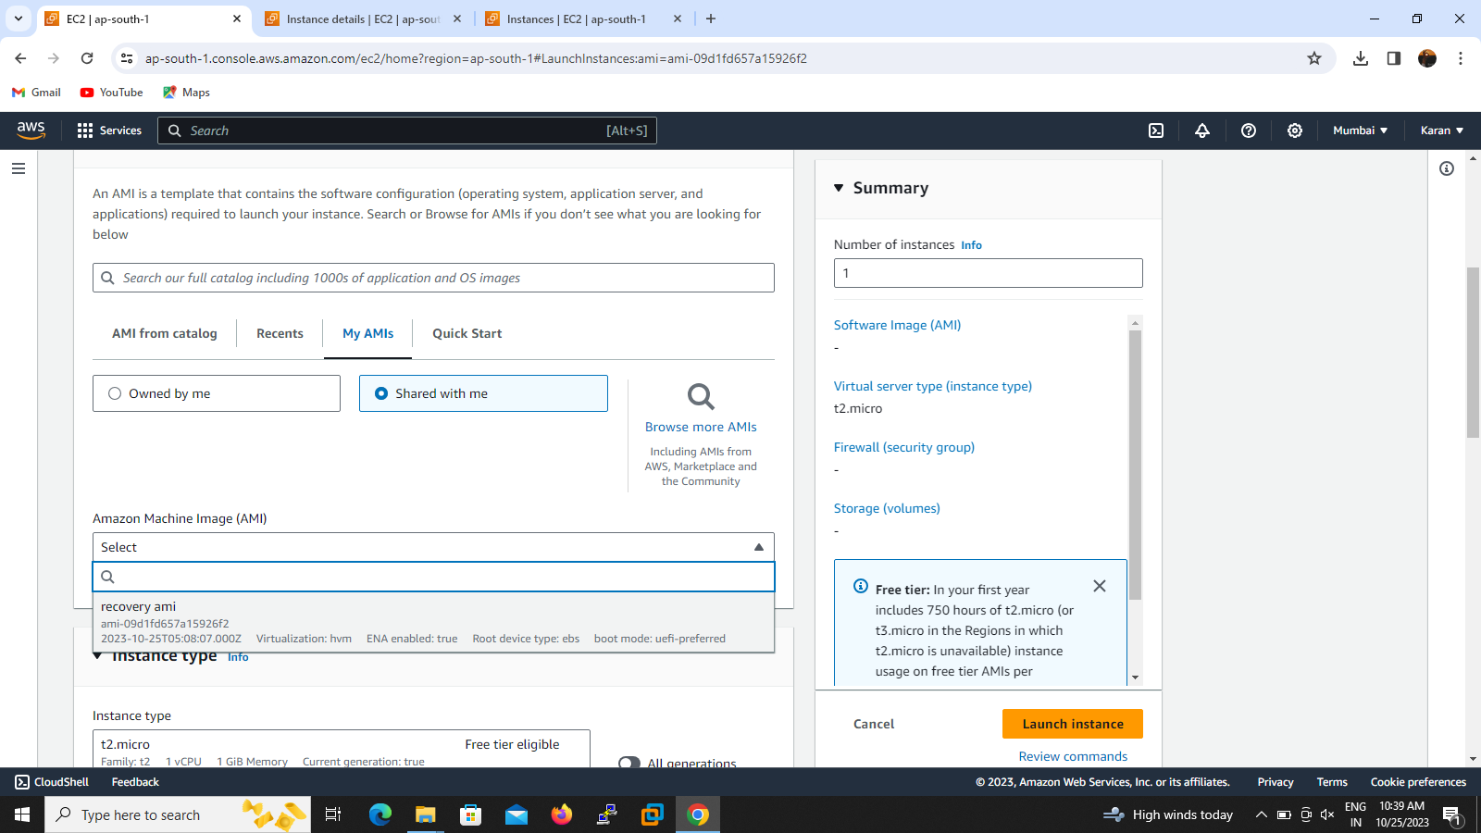

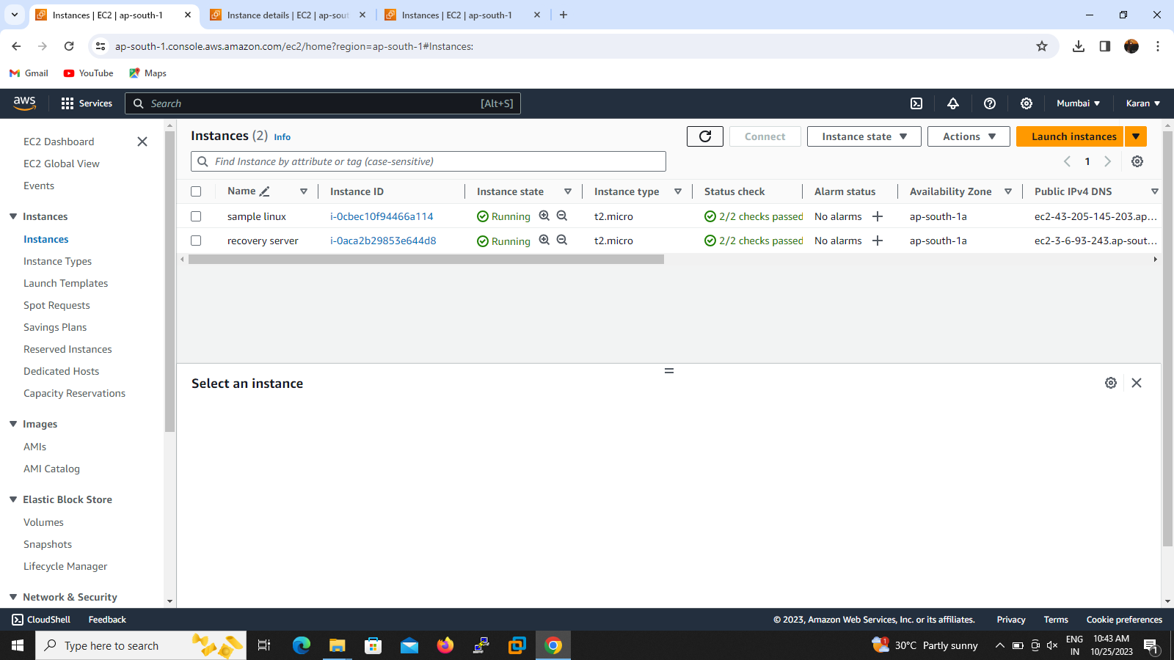

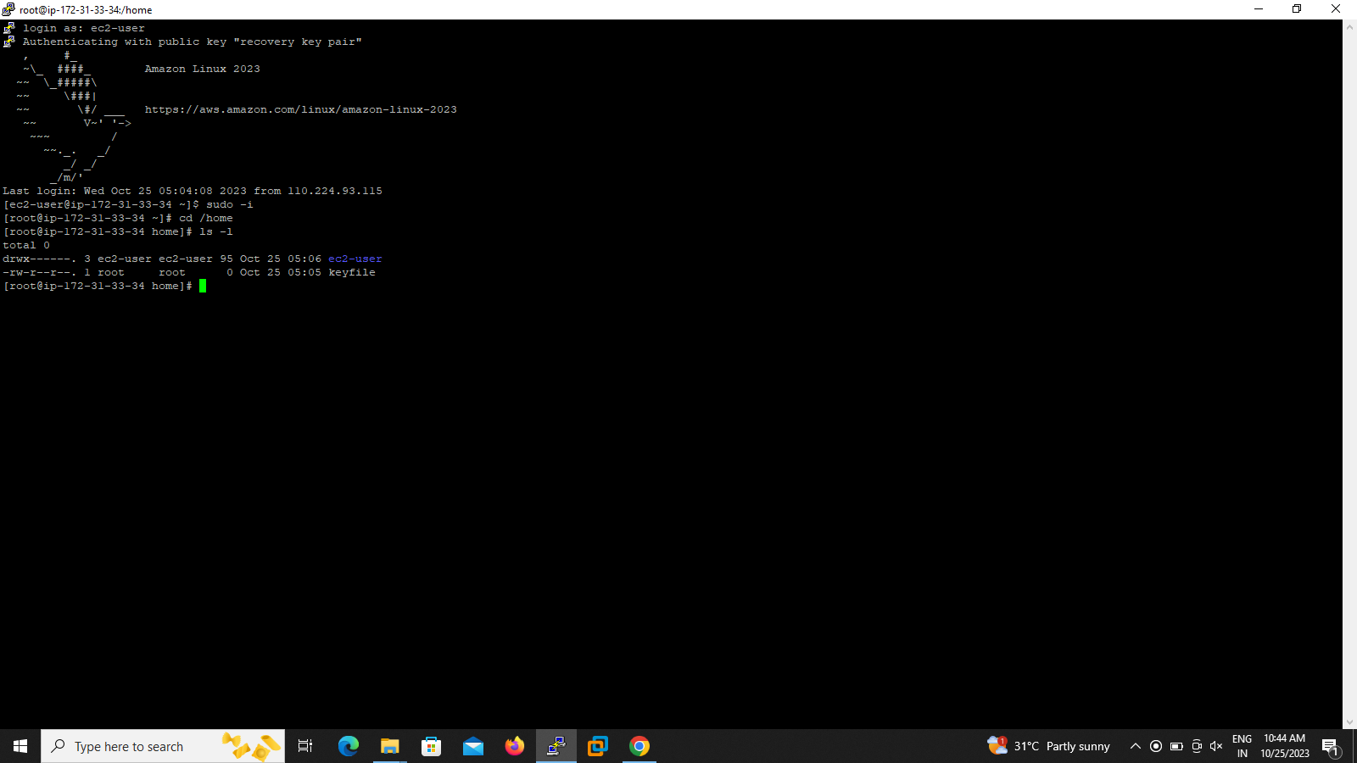

3.launch the instance from AMI id

4.login to putty by a new key file and available public ip address

5.check the file which sampling created

6 cd /home/key file

7.successfully recovered without data lose